**2.Servlet Container:**

* It provides the runtime environment for JavaEE (j2ee) applications.
* The client/user can request only a static WebPages from the server.
* If the user wants to read the web pages as per input then the servlet container is used in java.
* The servlet container is the part of web server which can be run in a separate process.

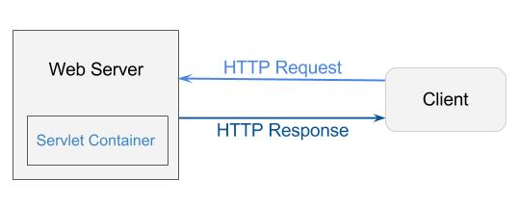

**Servlet Container:**

* It provides the runtime environment for JavaEE (j2ee) applications.
* The client/user can request only a static WebPages from the server.
* If the user wants to read the web pages as per input then the servlet container is used in java.
* The servlet container is the part of web server which can be run in a separate process.

**Servlet Container States:**

* The servlet container is the part of web server which can be run in a separate process. We can classify the servlet container states in three types:

1. **Standalone:**

* It is typical Java-based servers in which the servlet container and the web servers are the integral part of a single program.
* For example:- Tomcat running by itself

1. **In-process:**

* It is separated from the web server, because a different program runs within the address space of the main server as a plug-in.
* For example:- Tomcat running inside the JBoss.

1. **Out-of-process:**

* The web server and servlet container are different programs which are run in a different process.
* For performing the communications between them, web server uses the plug-in provided by the servlet container.